10. A* Algorithm
Aim
To write a Python program to implement the A search algorithm*.
Procedure
- Define the graph and heuristic values.
- Set the starting node.
- Calculate f(n) = g(n) + h(n).
- Select the node having the lowest f(n).
- Expand its neighbouring nodes.
- Continue until the goal node is reached.
- Display the shortest path.
Program
import heapqgraph = { 'A': [('B', 1), ('C', 3)], 'B': [('D', 3), ('E', 1)], 'C': [('F', 2)], 'D': [('G', 2)], 'E': [('G', 2)], 'F': [('G', 1)], 'G': []}h = { 'A': 6, 'B': 4, 'C': 4, 'D': 2, 'E': 2, 'F': 1, 'G': 0}def astar(start, goal): queue = [(h[start], 0, start, [start])] visited = set() while queue: f, g, node, path = heapq.heappop(queue) if node == goal: return path, g if node in visited: continue visited.add(node)
Output:
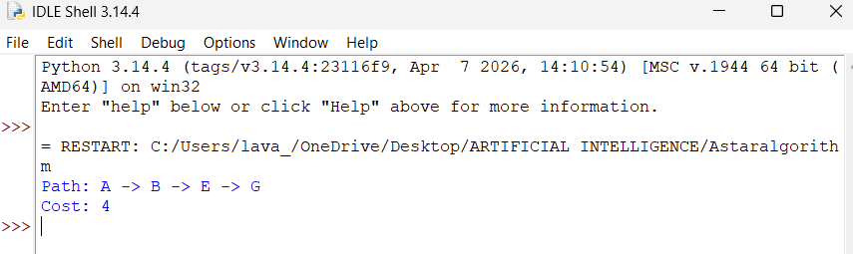
Result
Thus, the A algorithm was successfully implemented to find the optimal path from the start node to the goal node*.

